Parts coordinator – ( Regional warehouse spare request to SO DO )

L2 SUPPORT Assigned the service call to parts coordinator .

Parts coordinator select the regional warehouse.

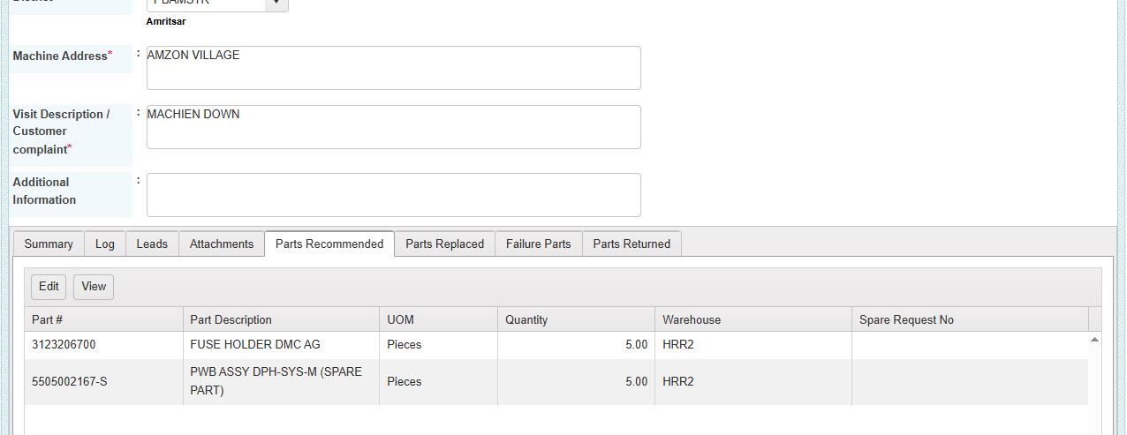

Gnerate the spare request from the service call , click the link and go to the spare request Module .spare request is assigned for the approval

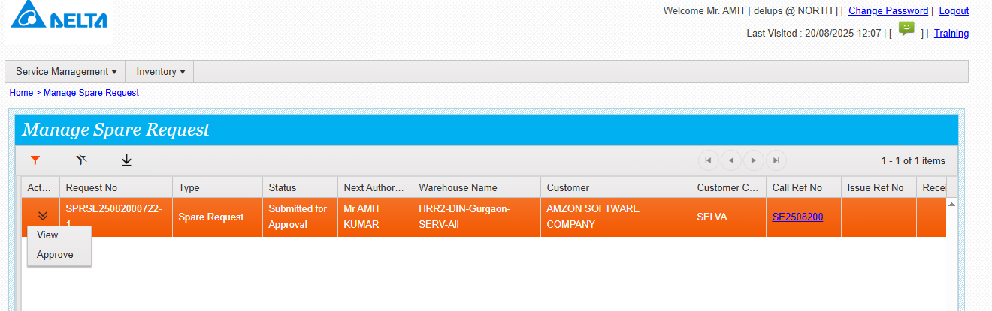

Click on approve and see the below screen , enter the required details and submit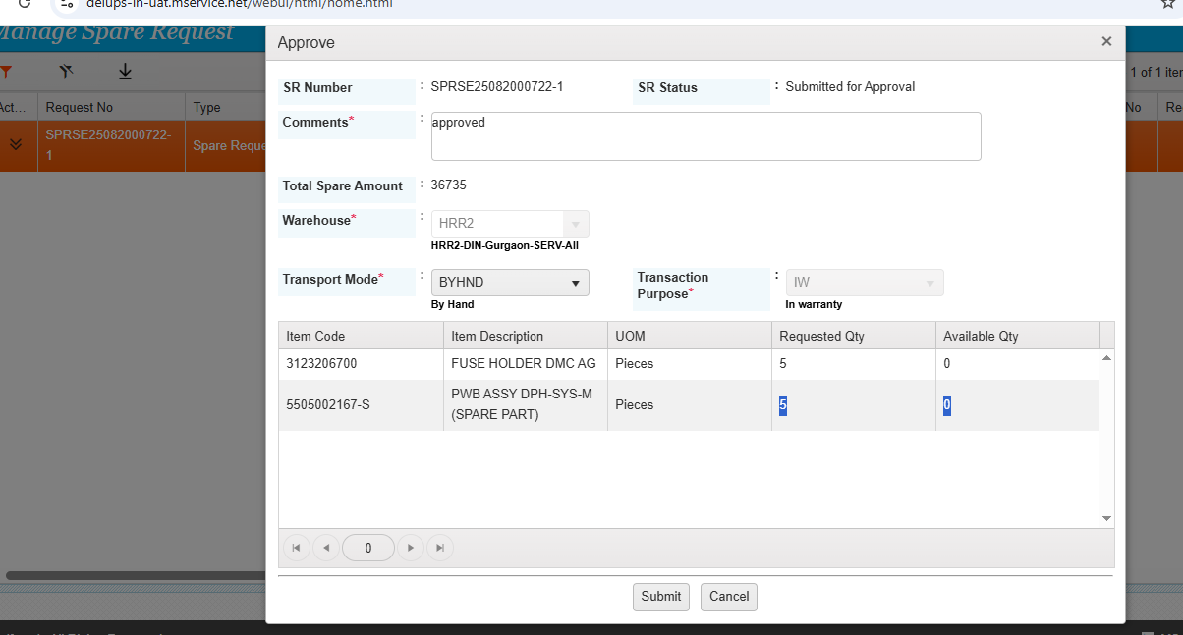

Once the spare request is approved then issue will be generated

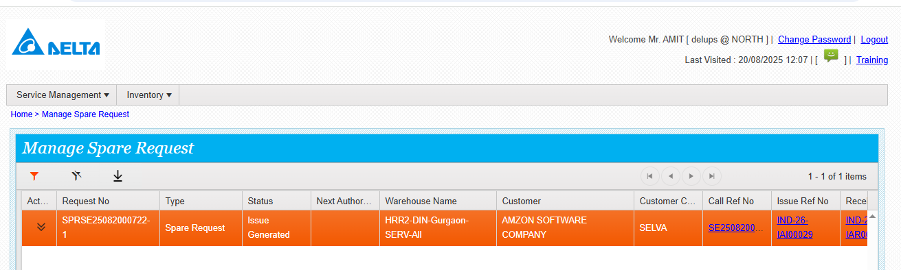

Click on the issue and go to the issue module/ issue awaiting for SO DO

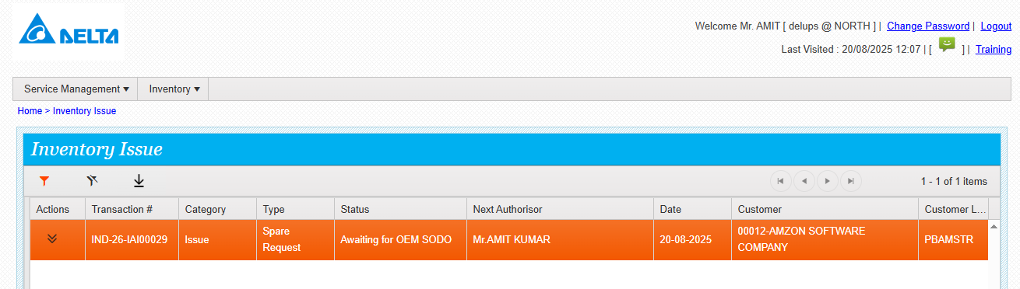

GO TO action and click so do update

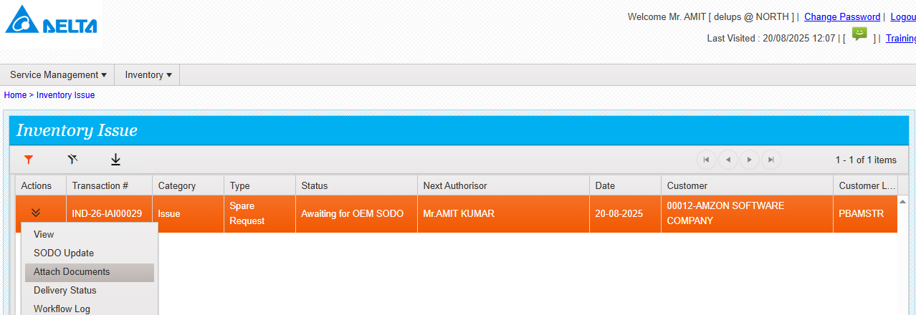

Enter the required details and submit

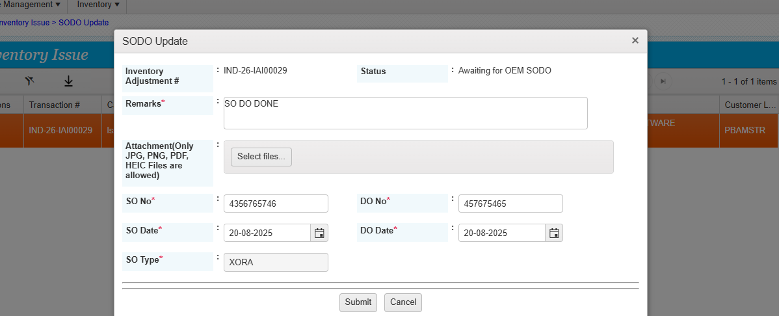

SO DO DONE successfully

